## **Day 1 Activity File: ELK Installation**

Today, you will configure an ELK server within your virtual network. Specifically, you will:

1. Create a new vNet in a new region, within your resource group.

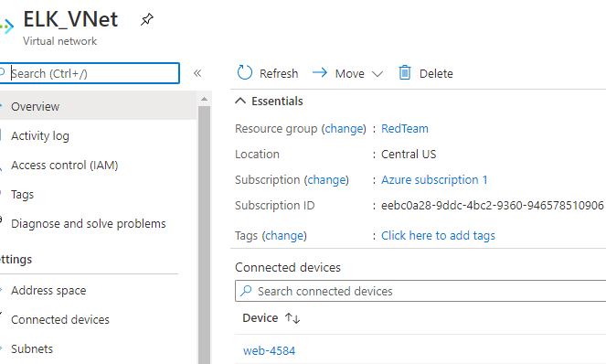

2. Create a Peer Network Connection between your two vNets.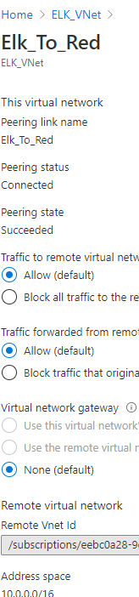

3. Create a new VM. Deploy a new VM into the new vNet with it's own Security Group. This VM will host the ELK server.

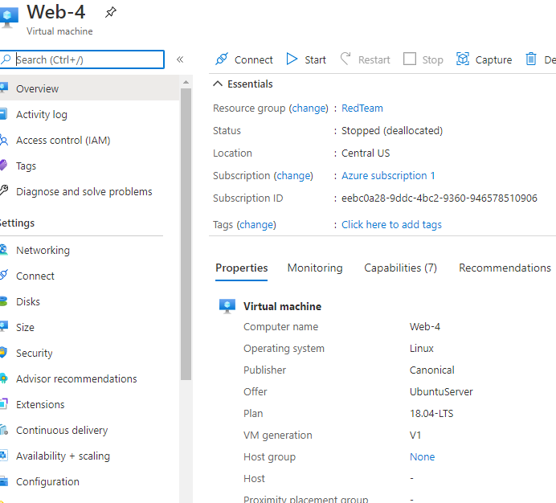

4. Download and configure a container. Download and configure the elk-docker container onto this new VM.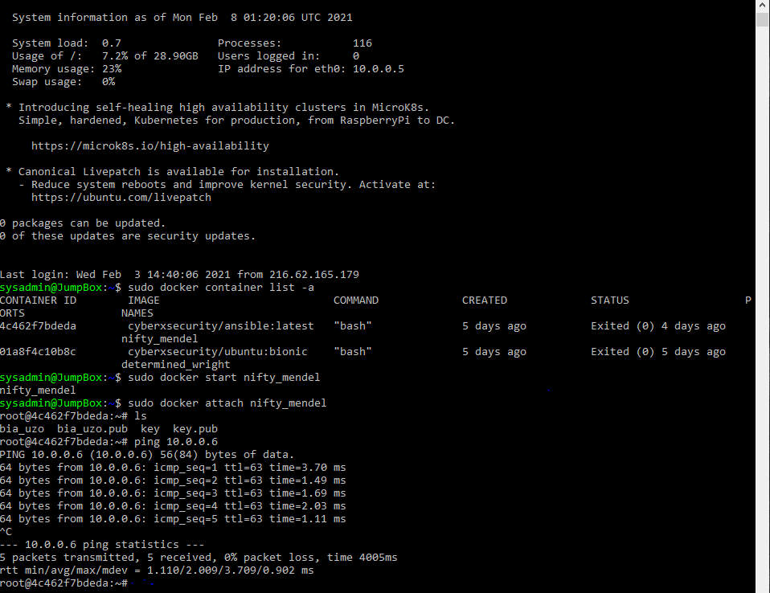

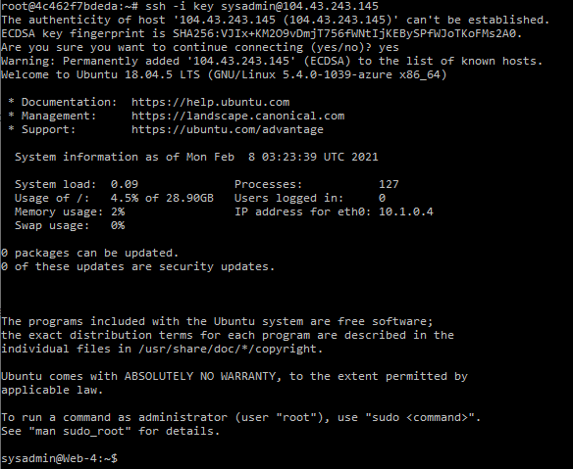

5. Launch and expose the container. Launch the elk-docker container to start the ELK server.

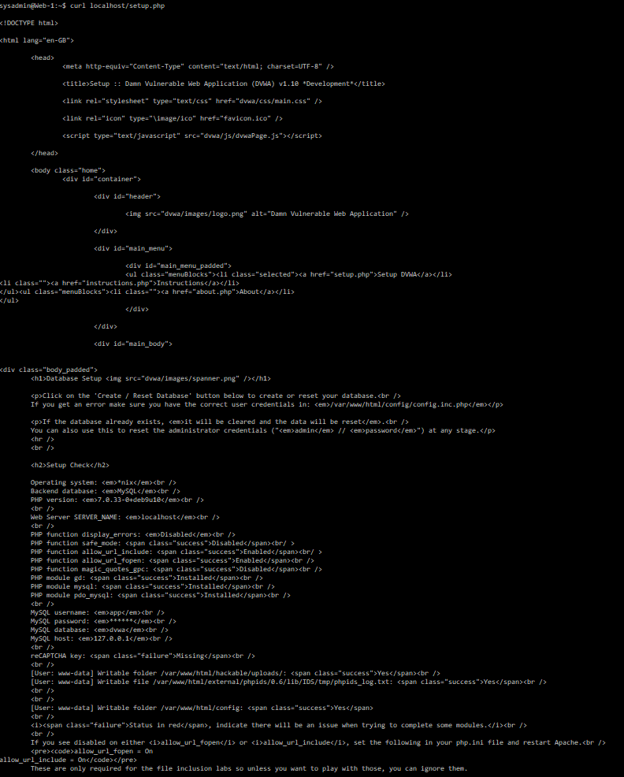

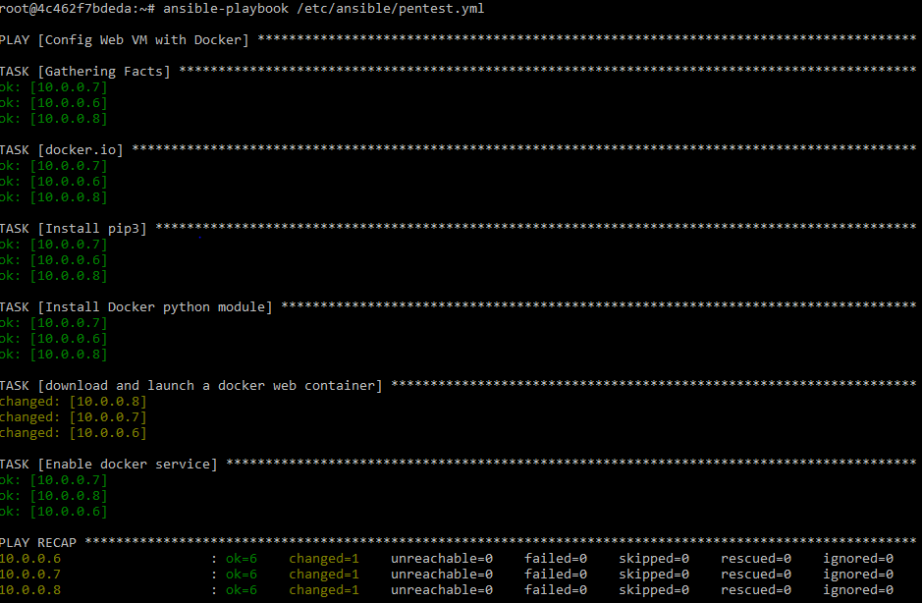

6.Implement identity and access management. Configure your new Security group so you can connect to ELK via HTTP, and view it through the browser.

